**Chapter 3**





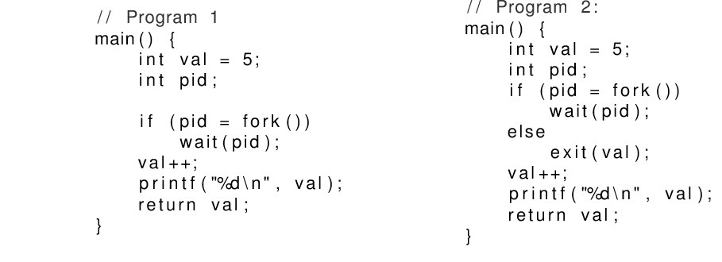

*Solution*:

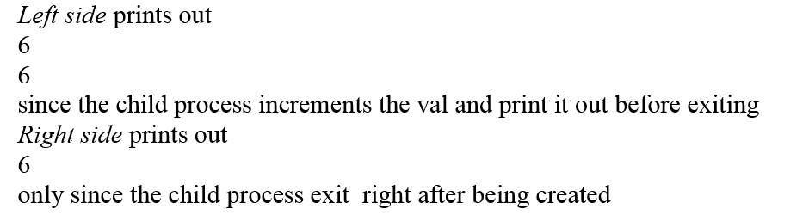

**Chapter 4**

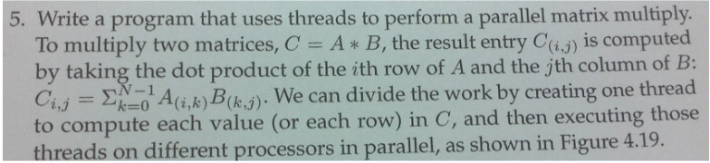

#include <pthread.h>

#include <stdio.h>

#include <math.h>

const int ROW, COLA, COL, TOTAL_THREADS = ROW * COL;

pthread_t tid[TOTAL_CUBE];

int a[ROW][COLA], b[COLA][COL], c[ROW][COL];

typedef struct node {

int i;

int j;

} Indices;

void *matrix(void *);

int main() {

// should initialize matrixes A and B first

for (int i = 0; i < ROW; i++)

for (int j = 0; j < COL; j++)

{

Indices inices;

indices.i = i;

indices.j = j;

pthread_create(&tid[i*COL+j], NULL, matrix, &indices);

}

for (int i = 0; i < TOTAL_THREADS; i++)

pthread_join(tid[i], NULL);

for (int i = 0; i < ROW; i++)

for (int j = 0; j < COL; j++)

printf("c[%d][%d] = %d\n", i, j, c[i][j]);

return 0;

}

void *matrix(void *indices) {

Indices *p = (Indices *)indices;

c[p->i][p->j] = 0;

for(int k=0;k<COLA;k++)

c[p->i][p->j] += a[p->i][k] * b[k][p->j];

pthread_exit(NULL);

}